**Homework 5**

Problem 1.

Create a Web Page like the following

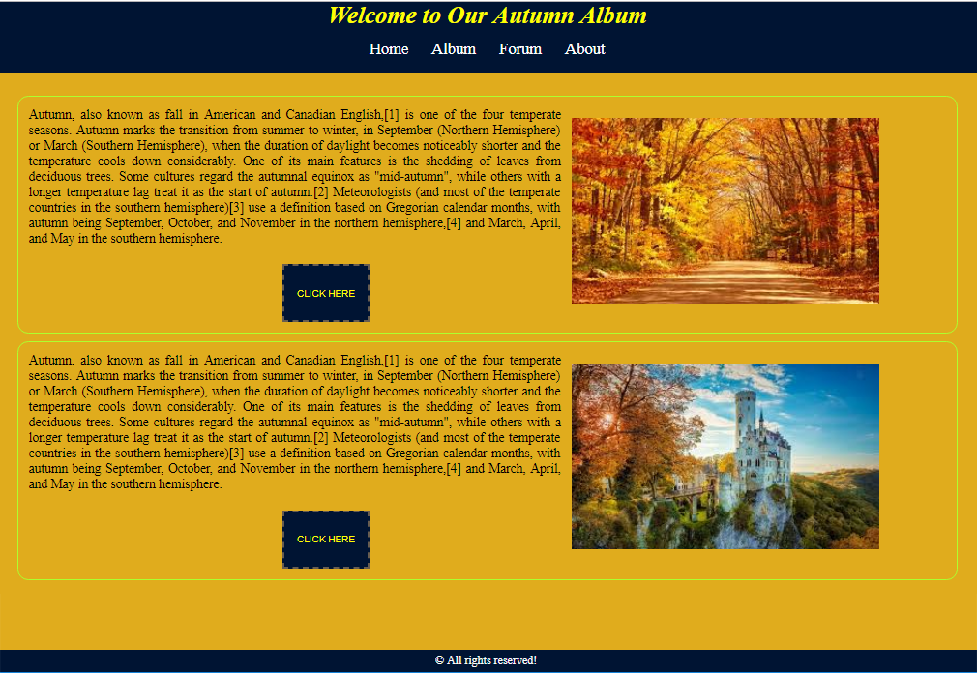

Create file: "**Golden-Autumn.css**"

You are **NOT** allowed to change the HTML file.

### Constrains

* <body>
  + Background: **#bc6c09;**
* **<p>**
  + Color : **black**;
  + Font-size : **18px**;
* **<h1>**
  + Padding:**5px**;
  + Color: **yellow**;
  + Italic
* **<header>**
* background-color: #001433;
* color: #fff;
* font-size: 22px;
* text-align: center;
* padding: 0;
* margin:0;
* **<section>**
  + Height: **900px**;
  + Padding: **20px**;
  + Margin on top : **100px**;
  + Background**: #e0ac1d**;
  + Radius on border: **15px**;
  + Text-align**: justify**;
  + Text-justify: **inter-word**;
* **Button**
  + Border: **2px dashed**;
  + Border-Color: **#685d50**;
  + Background: **#001433**;
  + Color :**yellow**;
  + Width: **120px**;
  + Height: **80px**;
  + Left margin: **350px**;
  + Top margin: **25px**;
  + Uppercase the text
* **Make hover on <a> and <button>**
  + Color: **red**;
  + Background: **#e8f3f4**;
  + Italic
* **<footer>**
  + Color: **white**;
  + Center the text
  + Padding: **15px**;
  + Background: **#001433**;